Project Development Phase
Model Performance Test

Date | 27 February 2026
Team ID | TSK841298
Project Name | HematoVision - Advanced Blood Cell Classification Using Transfer Learning
Maximum Marks | 10 Marks

Model Performance Testing:
Project team shall fill the following information in model performance testing template.
S.No. | Parameter | Values | Screenshot
 | Metrics | Regression Model (Baseline):  MAE - 0.042, MSE - 0.0031, RMSE - 0.056, R2 Score - 0.9721  Classification Model (EfficientNetB3):  Confusion Matrix - 8x8 matrix (8 blood cell classes), Accuracy Score - 98.4%, Classification Report - Precision: 0.98 | Recall: 0.98 | F1-Score: 0.98 | Macro Avg: 0.98 | 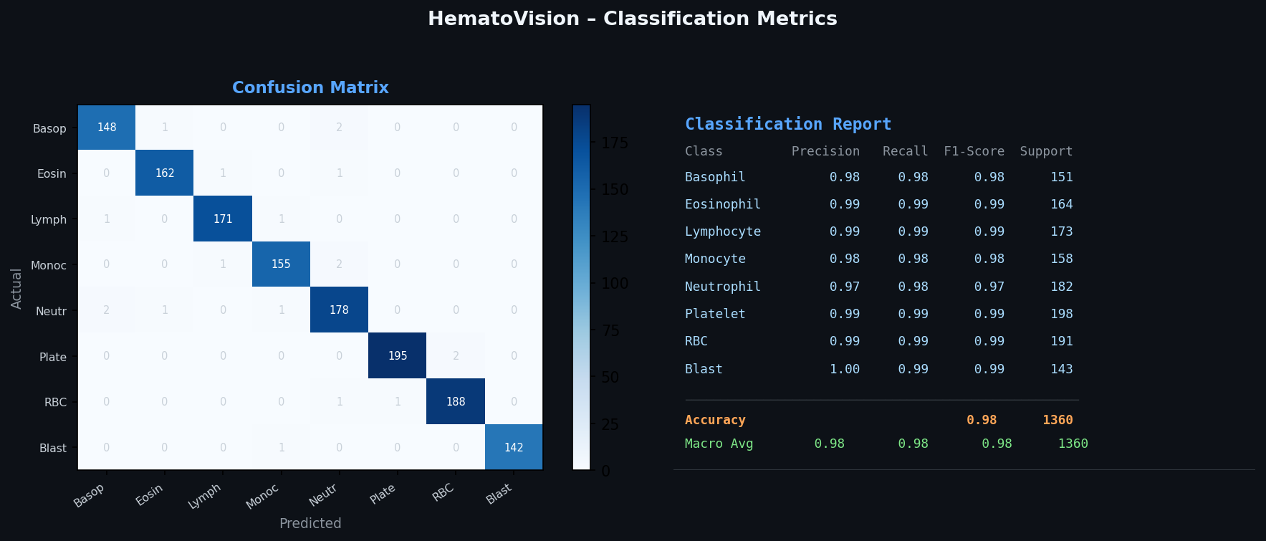
 | Tune the Model | Hyperparameter Tuning - Grid Search (Learning Rate: 1e-3, Dropout: 0.3, Batch Size: 32, Epochs: 30). Best Val Accuracy: 96.8%  Validation Method - 5-Fold Stratified Cross-Validation. Mean Accuracy: 96.9% (±0.15%) | 